

**Universidad Nacional de La Matanza**

# Departamento de Ingeniería e Investigaciones Tecnológicas

Redes de Computadoras

**TP INTEGRADOR**

**Grupo 4**

**Docentes:**

Carlos Binker

Martín Vilariño

Diego Fernández

Eliseo Zurdo

**Alumnos / Grupo:**

BIANCHI, JUAN ALBERTO (30475902)  
BOURDIEU, MARÍA DEL PILAR (45289653)  
 BROCANI, AGUSTIN NICOLAS (40931870)  
BURSA, KAREN ANABELLA (39978556)  
DEL VECCHIO, FABRIZIO (45688390)  
NIELSEN, TOMÁS AGUSTÍN (41326589)

**Cuatrimestre: 2°**

**Año lectivo: 2024**

**Topologia Utilizada:**

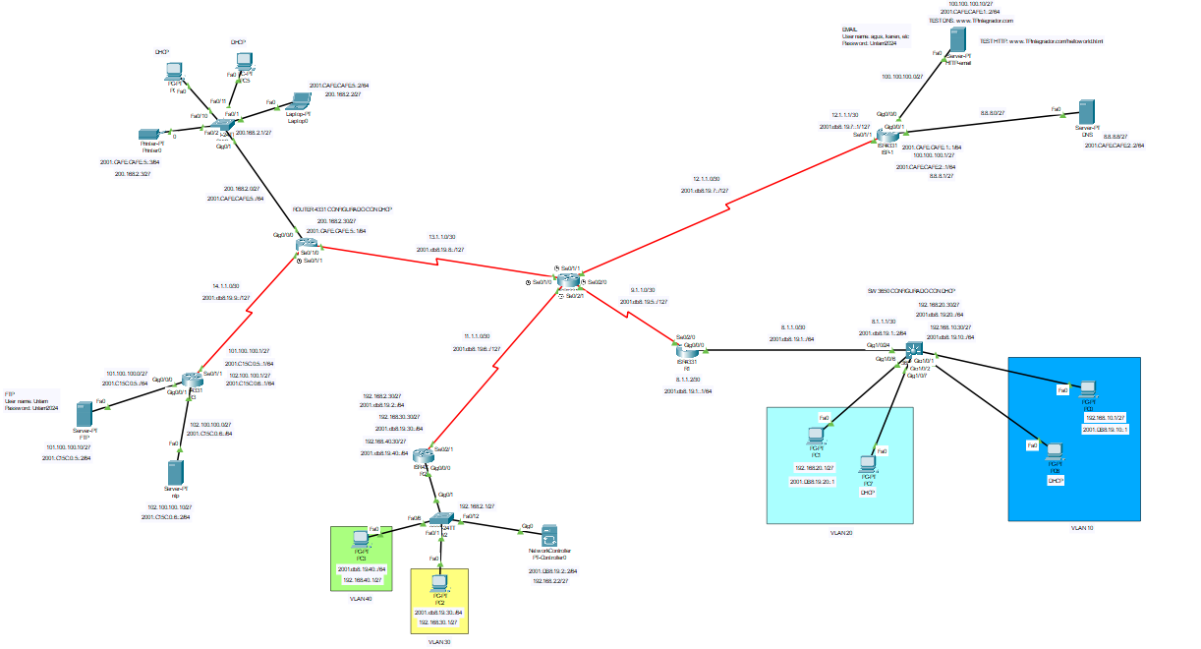

**Tablas de enrutamiento:**

**Direcciones IPV4**

|  |  |  |  |
| --- | --- | --- | --- |
| Dispositivo | Interfaz | Direccion ip | Mascara de subred |
| SW1(3650) | VLAN20, NAME PERTH | 192.168.20.30/27 | 255.255.255.0 |
| VLAN10, NAME BRISBANE. | 192.168.10.30/27 | 255.255.255.0 |
| G1/0/24 | 8.1.1.1/30 | 255.255.255.252 |
| R1(4331) | G0/0/0 | 8.1.1.2/30 | 255.255.255.252 |
| S0/2/0 | 9.1.1.1/30 | 255.255.255.252 |
| R5(4331) | SE0/2/0 | 9.1.1.2/30 | 255.255.255.252 |
| SE0/1/1 | 12.1.1.2/30 | 255.255.255.252 |
| SE0/2/1 | 11.1.1.0/30 | 255.255.255.252 |
| SE0/1/0 | 13.1.1.2/30 | 255.255.255.252 |
| R2(4331) | SE0/2/1 | 11.1.1.1/30 | 255.255.255.252 |
| G0/0/0.1 VLAN | 192.168.2.30/27 | 255.255.255.224 |
| G0/0/0.30 VLAN | 192.168.30.30/27 | 255.255.255.224 |
| G0/0/0.40 VLAN | 192.168.40.30/27 | 255.255.255.224 |
| R3(4331) | SE0/1/1 | 14.1.1.2/30 | 255.255.255.252 |
| G0/0/0 | 101.100.100.1/27 | 255.255.255.224 |
| G0/0/1 | 102.100.100.1/27 | 255.255.255.224 |
| R4(4331) | SE0/1/0 | 13.1.1.1/30 | 255.255.255.252 |
| SE0/1/1 | 14.1.1.1/30 | 255.255.255.252 |
| G0/0/0 | 200.168.2.30/27 | 255.255.255.224 |
| ISP-1(4331) | SE0/1/1 | 12.1.1.1/30 | 255.255.255.252 |
| G0/0/0 | 100.100.100.1/27 | 255.255.255.224 |
| G0/0/0/1 | 8.8.8.1/27 | 255.255.255.224 |
| PC0 | FA0 | 192.168.10.1/27 | 255.255.255.224 |
| PC1 | FA0 | 192.168.20.1/27 | 255.255.255.224 |
| PC2 | FA0 | 192.168.30.1/27 | 255.255.255.224 |
| PC3 | FA0 | 192.168.40.1/27 | 255.255.255.224 |
| LAPTOP0 | FA0 | 200.168.2.2/27 | 255.255.255.224 |
| PRINTER0 | FA0 | 200.168.2.3/27 | 255.255.255.224 |
| SERVER-PT-FTP | FA0 | 101.100.100.10/27 | 255.255.255.224 |
| SERVER-PT-NTP | FA0 | 102.100.100.10/27 | 255.255.255.224 |
| NETWORK-CONTROLLER | Gig0 | 192.168.2.2/27 | 255.255.255.224 |
| SERVER-PT-HTTP | FA0 | 100.100.100.10/27 | 255.255.255.224 |
| SERVER-PT-DNS | FA0 | 8.8.8.8/27 | 255.0.0.0 |
| PC4, PC5,PC6,PC7 | FA0 | CONFIGURADO CON DHCP | |

**Direcciones IPV6**

|  |  |  |  |
| --- | --- | --- | --- |
| dispositivo | interfaz | direccion ip | mascara de subred |
| SW1(3650) | VLAN20, NAME PERTH | 2001:db8:19:20:: | /64 |
| VLAN10, NAME BRISBANE. | 2001:db8:19:10:: | /64 |
| G1/0/24 | 2001:db8:19:1::2 | /64 |
| R1(4331) | G0/0/0 | 2001:db8:19:1::1 | /64 |
| S0/2/0 | 2001:db8:19:5:: | /127 |
| R5(4331) | SE0/2/0 | 2001:db8:19:5::1 | /127 |
| SE0/1/1 | 2001:db8:19:7:: | /127 |
| SE0/2/1 | 2001:db8:19:6:: | /127 |
| SE0/1/0 | 2001:db8:19:8:: | /127 |
| R2(4331) | SE0/2/1 | 2001:db8:19:6::1 | /64 |
| G0/0/0.1 VLAN | 2001:db8:19:2::1 | /64 |
| G0/0/0.30 VLAN | 2001:db8:19:30::1 | /64 |
| G0/0/0.40 VLAN | 2001:db8:19:40:: | /64 |
| R3(4331) | SE0/1/1 | 2001:db8:19:9:: | /127 |
| G0/0/0 | 2001:C15C:0:5::1 | /64 |
| G0/0/1 | 2001:C15C:0:6::1 | /64 |
| R4(4331) | SE0/1/0 | 2001:db8:19:8::1 | /127 |
| SE0/1/1 | 2001:db8:19:9::1 | /127 |
| G0/0/0 | 2001:CAFE:CAFE:5::1 | /64 |
| ISP-1(4331) | SE0/1/1 | 2001:db8:19:7::1 | /127 |
| G0/0/0 | 2001:CAFE:CAFE:1::1 | /64 |
| G0/0/0/1 | 2001:CAFE:CAFE:2::1 | /64 |
| PC0 | FA0 | 2001:DB8:19:10::1 | /64 |
| PC1 | FA0 | 2001:DB8:19:20::1 | /64 |
| PC2 | FA0 | 2001:db8:19:30::2 | /64 |
| PC3 | FA0 | 2001:db8:19:40::2 | /64 |
| LAPTOP0 | FA0 | 2001:CAFE:CAFE:5::2 | /64 |
| PRINTER0 | FA0 | 2001:CAFE:CAFE:5::3 | /64 |
| SERVER-PT-FTP | FA0 | 2001:C15C:0:5::2 | /64 |
| SERVER-PT-NTP | FA0 | 2001:C15C:0:6::1 | /64 |
| NETWORK-CONTROLLER | Gig0 | 2001:DB8:19:2::2 | /64 |
| SERVER-PT-HTTP | FA0 | 2001:CAFE:CAFE:1::2 | /64 |
| SERVER-PT-DNS | FA0 | 2001:CAFE:CAFE:2::2 | /64 |
| PC4, PC5,PC6,PC7 | FA0 | CONFIGURADO CON DHCP | |

**Protocolo de ruteo OSPF:**

Utilizamos este protocolo de ruteo dinámico para IPV4 e IPV6, implementando una única área (backbone) debido a que el tamaño de la red no nos pareció lo suficientemente grande como para incorporar más. A continuación, podrán visualizar los comandos que ingresamos para la configuración de uno de los router (en este caso el router de borde):

ipv6 router ospf 1

router-id 5.5.5.5

default-information originate

exit

interface serial0/1/0

ipv6 ospf 1 area 0

interface serial0/2/0

ipv6 ospf 1 area 0

interface serial0/2/1

ipv6 ospf 1 area 0

exit

router ospf 100

network 9.1.1.2 0.0.0.3 area 0

network 11.1.1.1 0.0.0.3 area 0

network 13.1.1.2 0.0.0.3 area 0

_A continuación se detallan las configuraciones solicitadas en las consignas

**CREACION DE DOMINIO E IP PUBLICA**

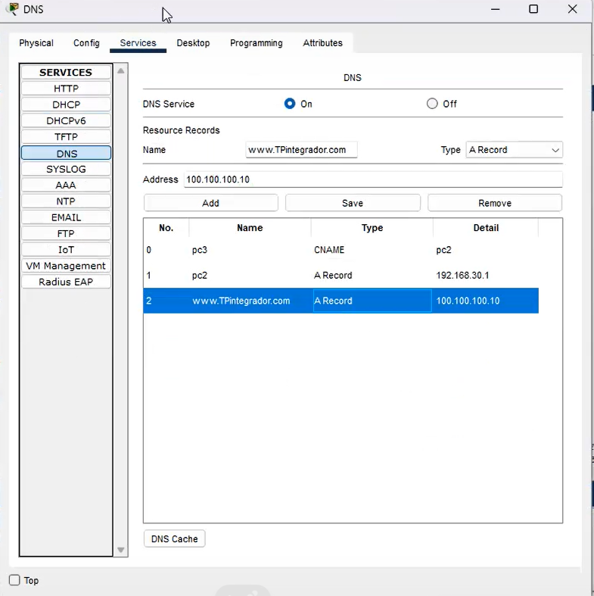

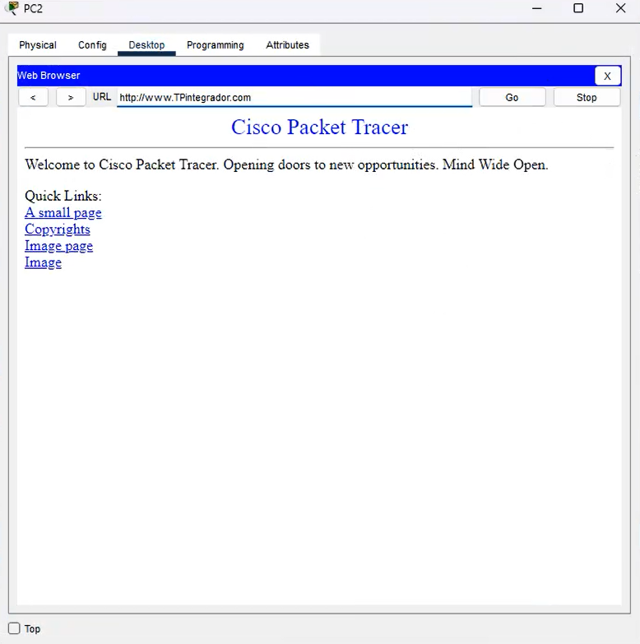

**Configuración NTP:**

R3

enable

configure terminal

ntp server 102.100.100.10

ntp update-calendar

end

write

show ntp associations // opcional

show clock // opcional

show ntp status // opcional

exit

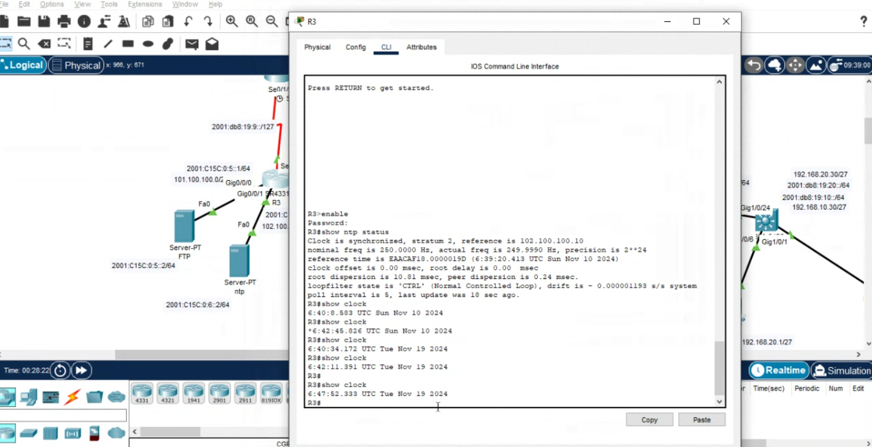

**Configuración FTP**

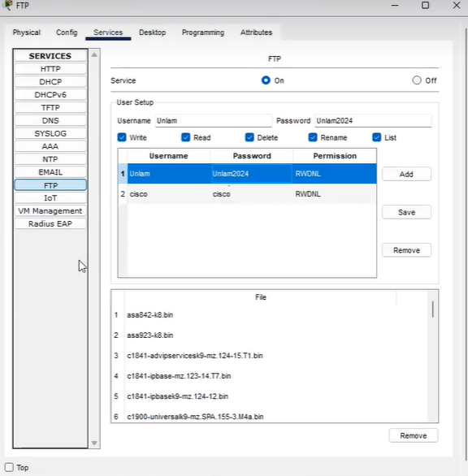

**PRUEBA EN PC3**

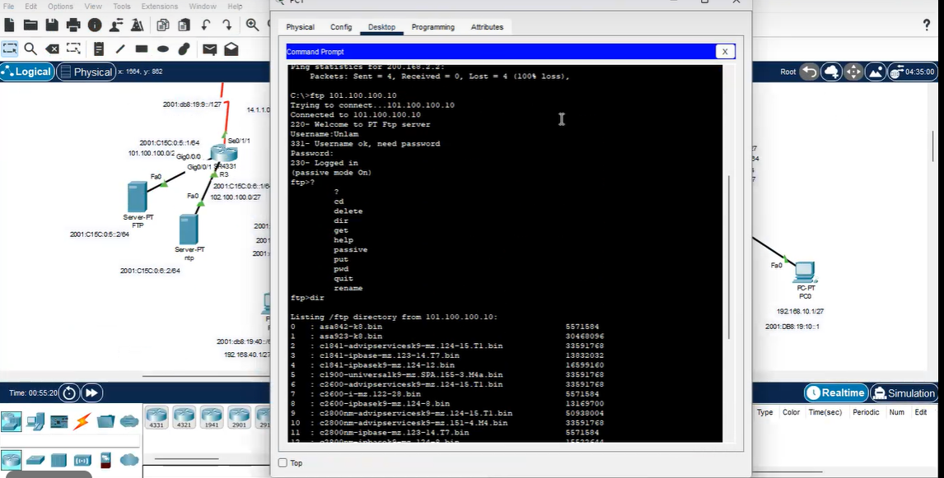

**CREACION DE EMAILS EN HTTP**

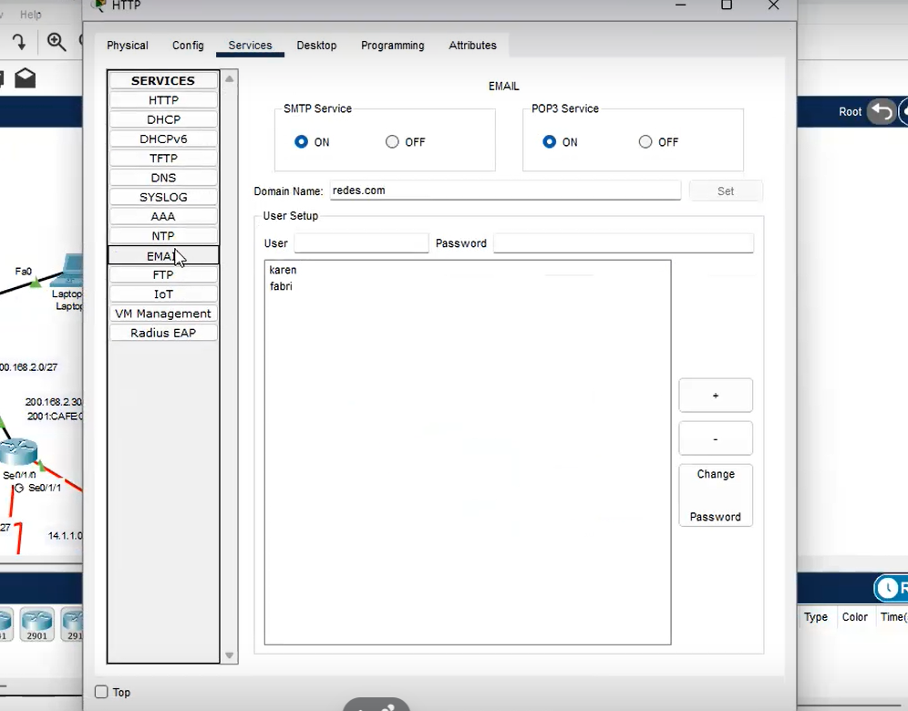

**PRUEBAS**

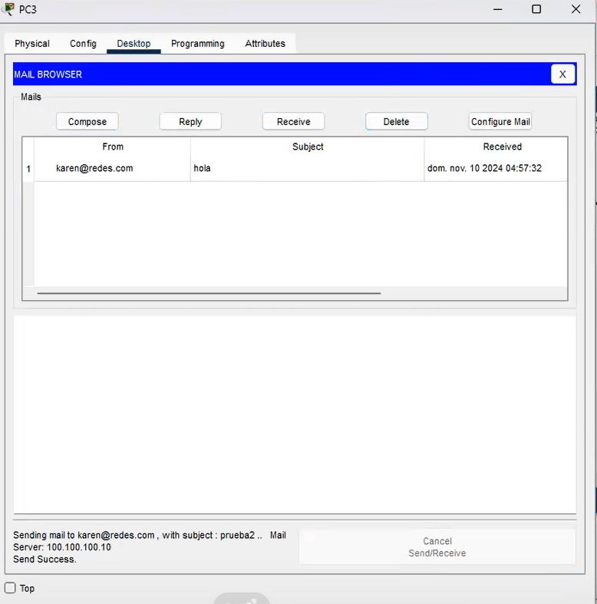

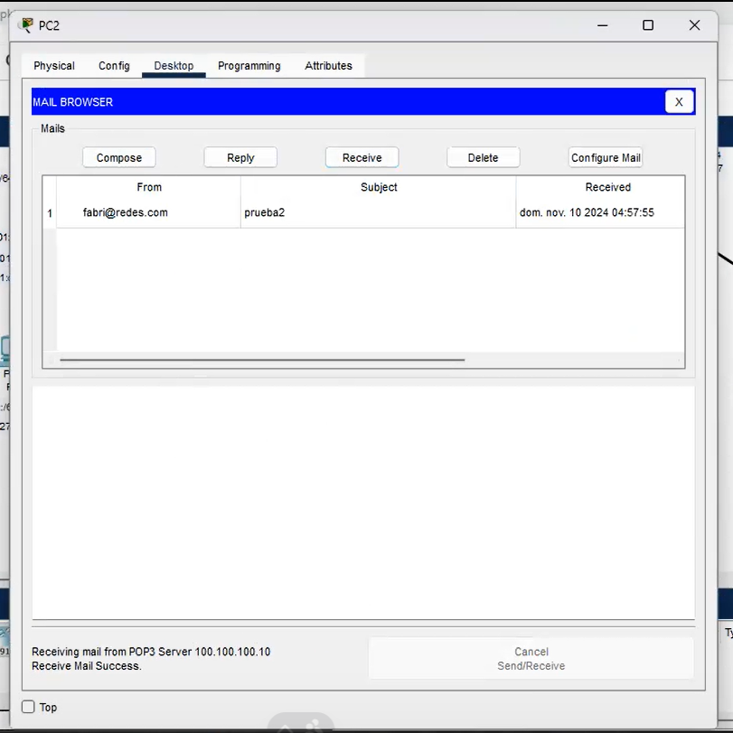

**Configuracion DNS**

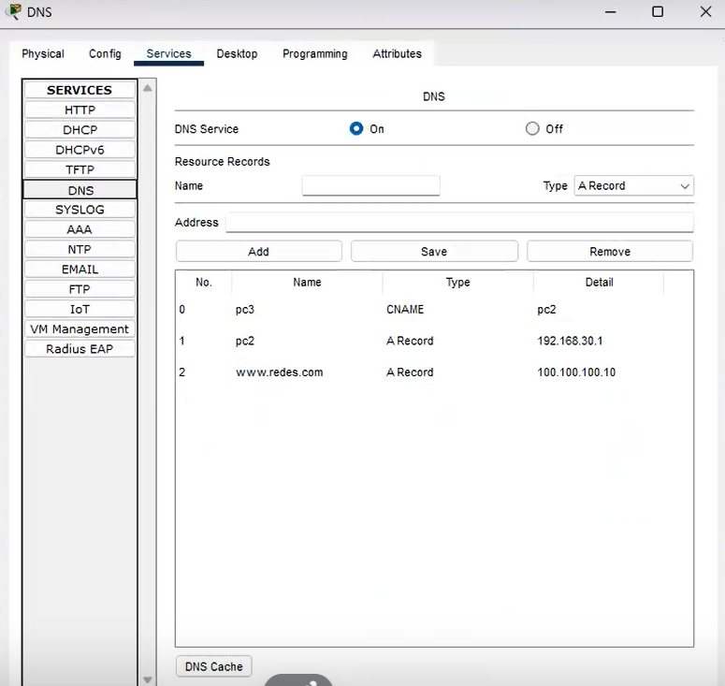

**pruebas**

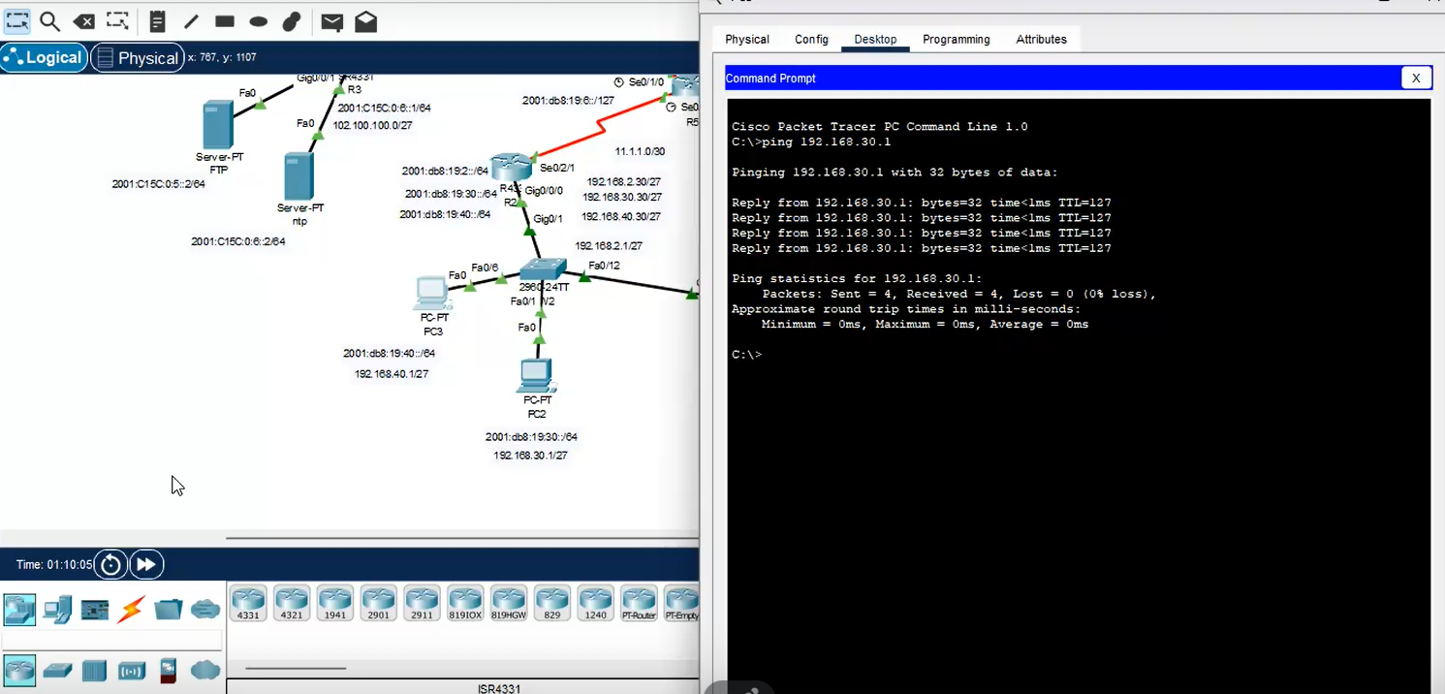

**CREACION DE CREDENCIAL**

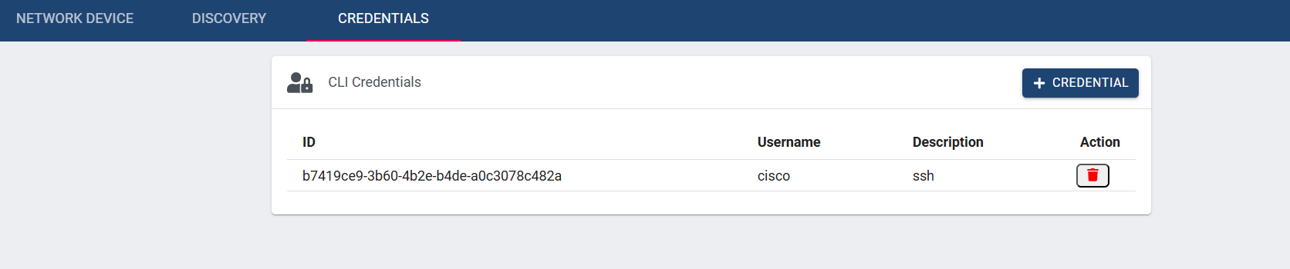

**Assurance**

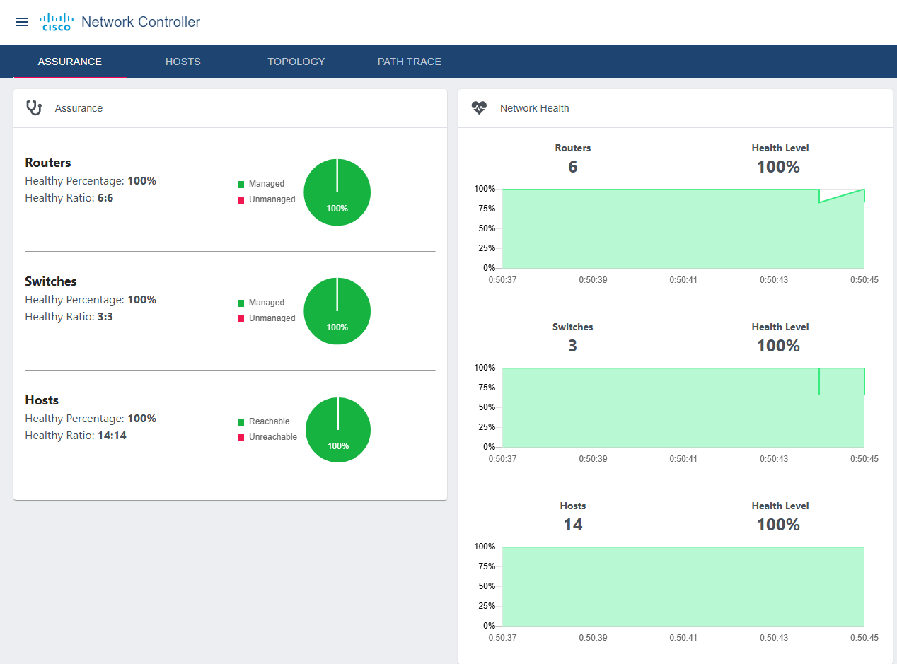

**TOPOLOGIA**

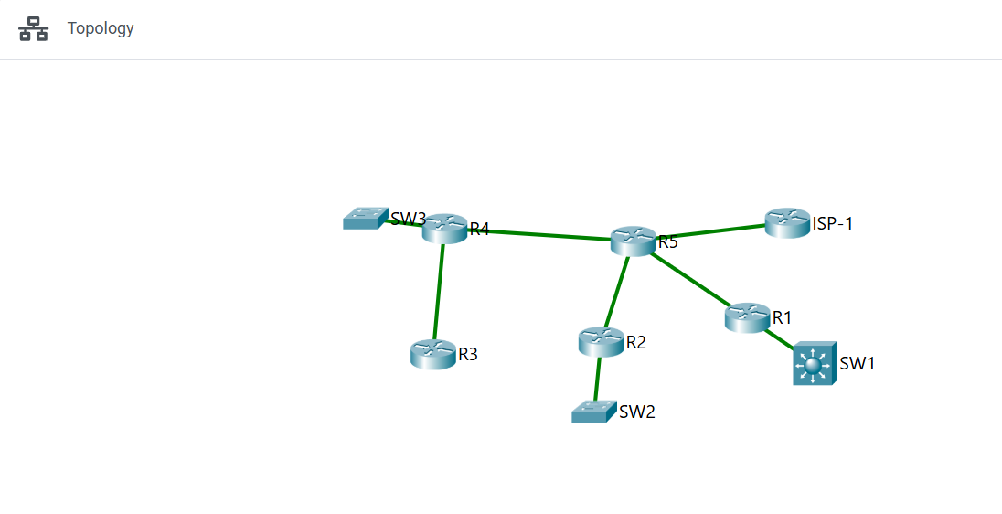

**Discovery Hecho**

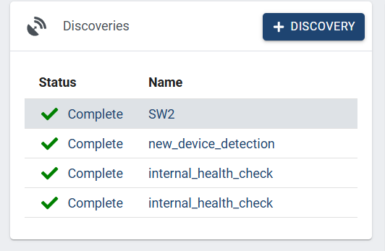

**Dispositivos de la red**

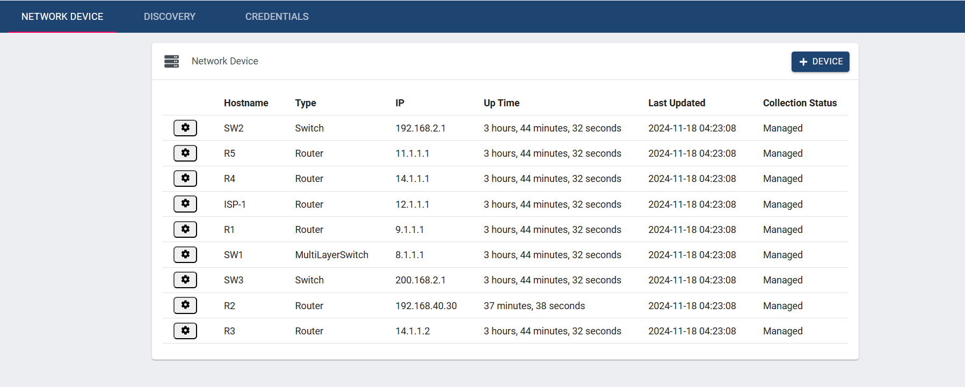

**Dashboard**

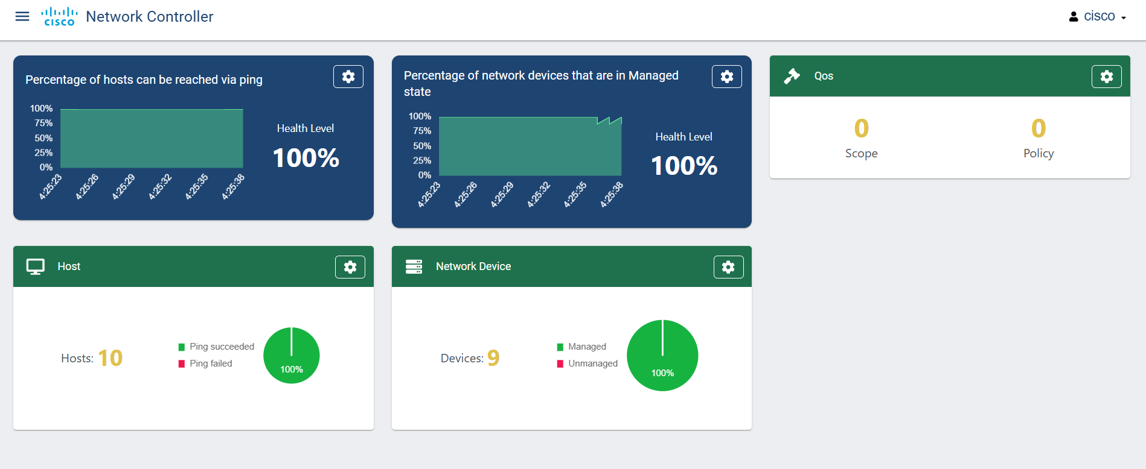

**Hosts**

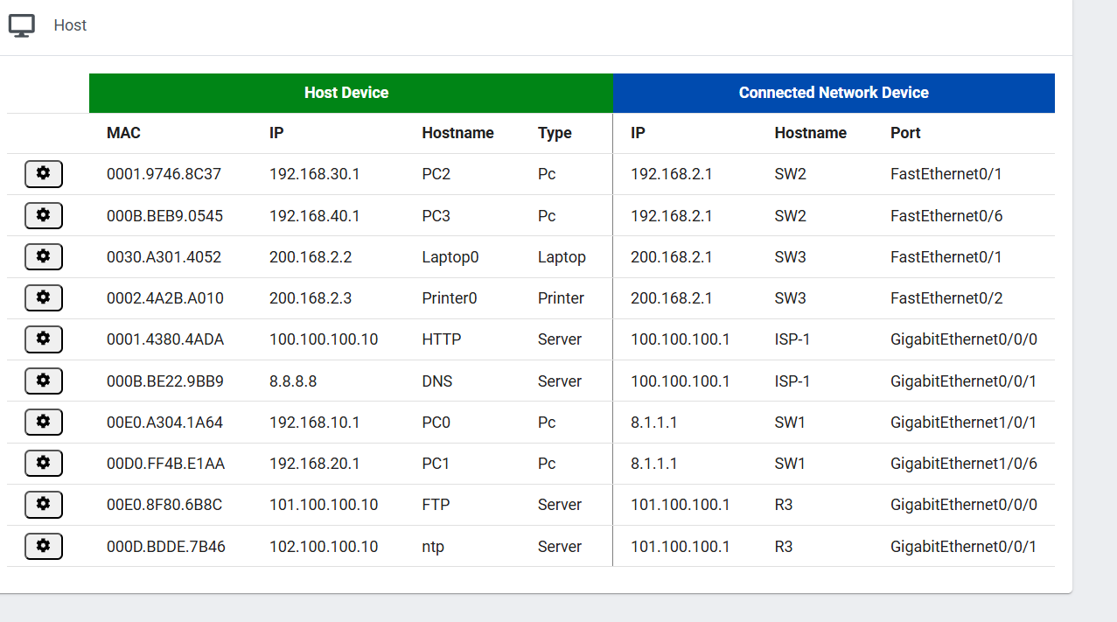

**APIS.**

En la resolución de esta sección se utilizo la herramienta POSTMAN para realizar las consultas CRUD

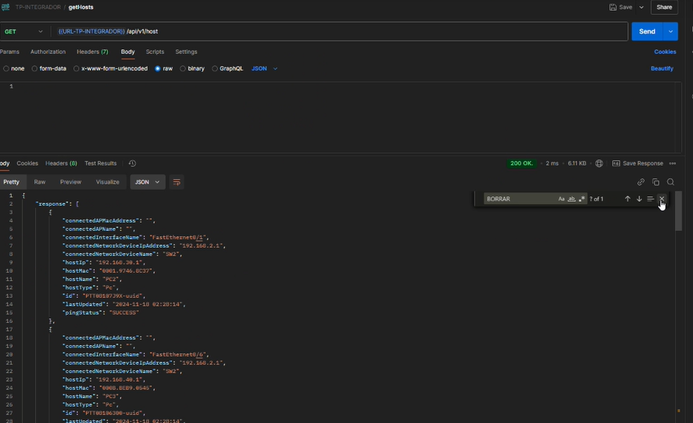obtener información de la topología con un get en POSTMAN

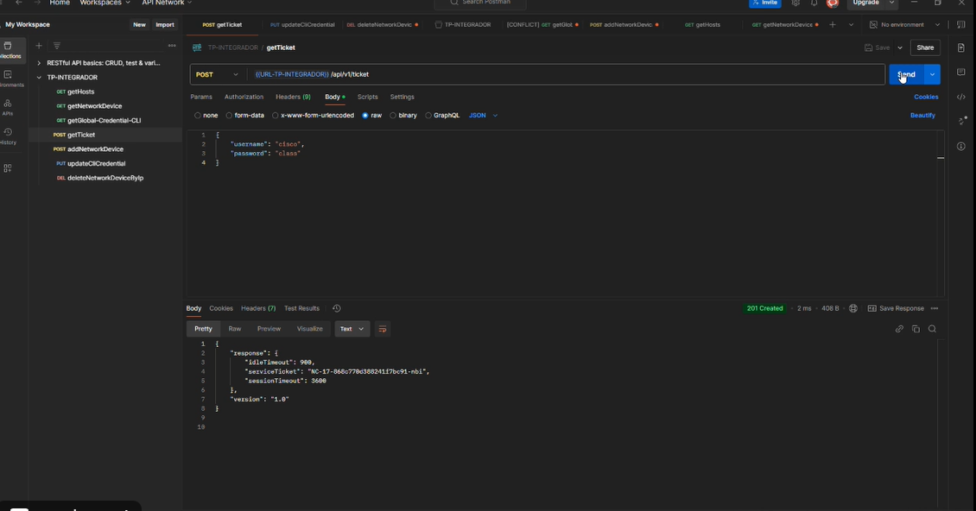

Creación de ticket

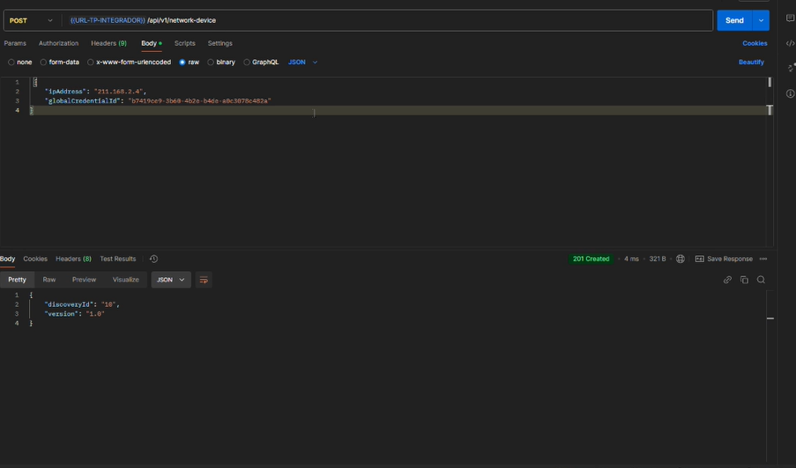Agregar una IP mediante POST

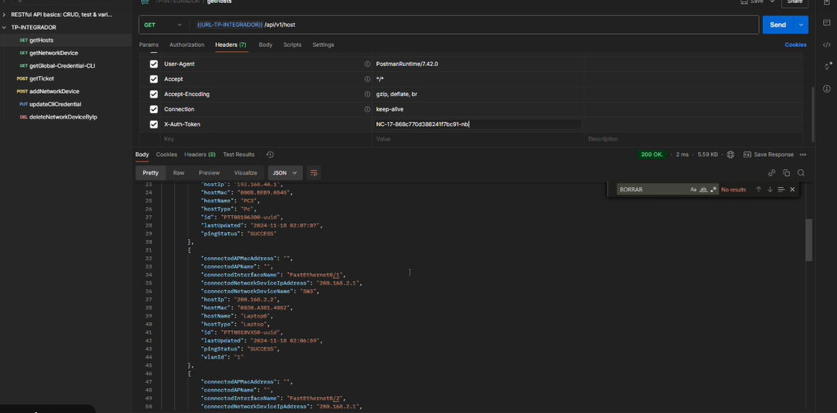

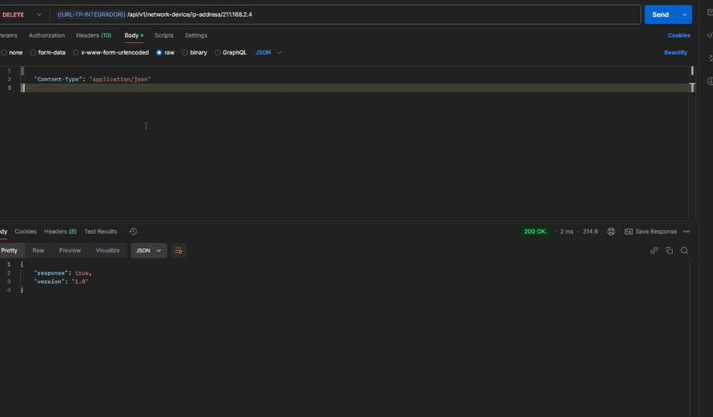delete de una IP

get para obtener información actualizada

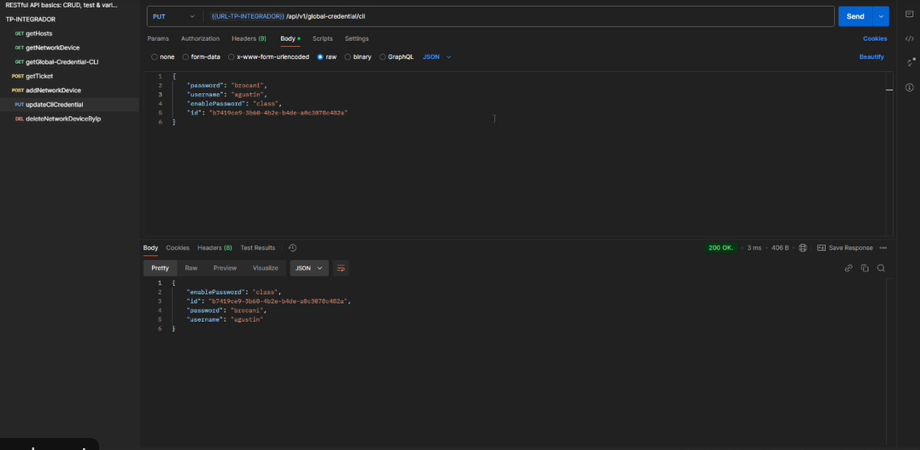

Creacion de credencial